From: http://www.seattletimes.com/seattle-news/lola-pulido-lived-life-of-devotion-to-family/
[The Original 2011] Obituary

Lola’ Pulido lived life of devotion to family
Originally published November 19, 2011 at 9:49 pm Updated May 19, 2017 at 5:07 pm
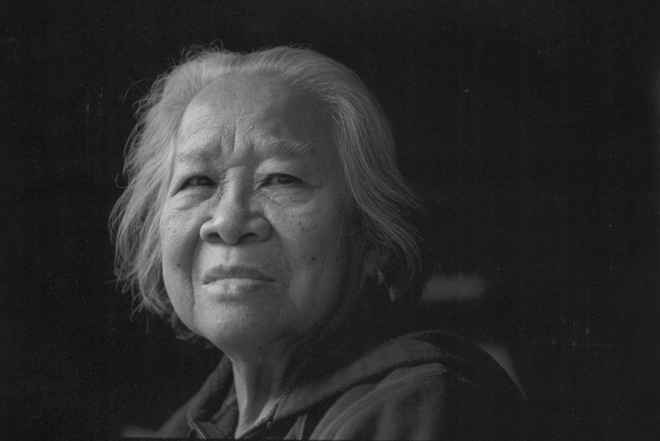Eudocia Tomas Pulido promised to take care of a 12-year-old girl, and ended up taking care of three generations of her family. (Alan Berner)

Eudocia Tomas Pulido lived a life marked by a devotion so rare that even those closest to her still struggle to comprehend it.

By
Susan Kelleher
Seattle Times staff reporter

Editor’s note (May 17, 2017): This obituary, published in 2011, was written at the suggestion of and after an extensive interview with Alex Tizon, a former Seattle Times reporter. This week, a story in the June 2017 issue of The Atlantic written by Tizon, who died earlier this year, describes Eudocia Tomas Pulido as a slave and details her relationship with his family spanning decades. Disparities between the magazine story and this obituary are addressed in this piece by Susan Kelleher.

Eudocia Tomas Pulido loved a good wedding, the more royal the better.
But she never married. Never even dated.
Miss Pulido would live a different kind of love story, one marked by a devotion so rare that even those closest to her still struggle to comprehend it.
As a teenager in the Philippines, Miss Pulido was asked to care for a young girl whose mother had died. When a relative asked Miss Pulido to always look after the girl, she gave her word.
Miss Pulido not only raised that girl, but the girl’s children and their children — cooking, cleaning and caring for three generations that came to know her as “Lola,” grandmother in her native Tagalog tongue. She asked for nothing in return, said her grandson, Alex Tizon, a former Seattle Times reporter, with whom she lived in Edmonds for nearly 12 years.
When Miss Pulido died Nov. 7 after a heart attack, she was surrounded by the small tribe that had become her own. She was 86.
Miss Pulido was born March 1, 1925, in a one-room house near the village of Mayantoc, north of Manila. The third of six children born to subsistence farmers, she was forced to quit school at an early age to work on the farm, Tizon said.
She learned to read late in life by studying the daily newspaper, and found pleasure doing word puzzles.
When Miss Pulido was 16, her family arranged for her to marry a 50-year-old man. But World War II intervened, and the man disappeared. Two years later, Miss Pulido was taken in by an Army colonel who needed someone to look after his 12-year-old daughter, Leticia Asuncion.
It was an odd relationship from the beginning. Miss Pulido served as mother, sister and protector, sometimes standing in for Asuncion when the colonel punished her for misbehaving, said Tizon.
Miss Pulido took care of Asuncion as the girl became a medical doctor in the United States and a mother of five.
“She cared for, protected, chaperoned and served my mother for 56 years, until my mother died of leukemia in 1999,” Tizon wrote in an email. “Lola never left my mother’s side. She was as devoted as any human being could be to another human being.”
While Asuncion and her husband worked, Miss Pulido ran the household and raised the children, offering advice, support, discipline and food, always food, said her granddaughter, Leticia Tizon Quillen of Edmonds.
Over the years, Miss Pulido cooked thousands of amazing meals from heart and from memory. But she could be fierce, too.
When boys started coming around to date Quillen and her sister, Miss Pulido let them know who was boss. Once, she emerged from the house with a baseball bat when a boy wouldn’t leave. Other times, she’d flick the porch light to announce her presence when the girls returned home from a date.
“She was only 4 feet 11 inches, but our boyfriends were afraid of her,” Quillen said.
After Asuncion died in 1999, Miss Pulido moved to Edmonds to live with Tizon’s family, and raised his two girls. She was a familiar sight along Edmonds Way, a tiny woman in baggy pants pushing her two-wheeled shopping cart a quarter mile to the QFC several times a week. When walking became difficult for her six years ago, Tizon and his wife drove her to 99 Ranch Market, where she smiled at the checkers and loaded up on vegetables and noodles.
Miss Pulido visited her blood family in the Philippines in her later years, and routinely gave half of her $600-a-month Social Security check to help people there repair houses damaged by monsoons, pay for weddings, schooling, funerals and medical care.
She talked often about returning to her village, Tizon said, but always found a reason to stay here.
She found joy in nickel slots and gardening, and collected flower seeds by the hundreds in baggies she stashed around her room. Miss Pulido could have had anything she wanted, Tizon said, but she seemed determined to leave with as little as she was born with, keeping all her worldly possessions in four cardboard boxes stashed in her closet.
“Growing up with Lola taught me that not calling attention to yourself was a perfectly fine and honorable way to live,” Tizon wrote. “She was never angst-ridden and never felt entitled to anything, including happiness. I think that’s one reason she was one of the most peaceful people I’ve ever known.”
Miss Pulido is survived by a brother, Crispin Pulido, and two sisters, Juliana Candelario and Gregoria Tomas — all in the Philippines. In addition to Tizon and Quillen, she is survived by five other children she raised: Art, Dylan and Maya Tizon, all of Edmonds; Albert Tizon of Philadelphia; and Maria Tizon Silbernagel of Salem, Ore.
A memorial service was held for Miss Pulido, and her cremated remains will be returned to the Philippines.

From: http://www.seattletimes.com/seattle-news/northwest/why-the-obituary-for-eudocia-tomas-pulido-didnt-tell-the-story-of-her-life-in-slavery/

Why the obituary for Eudocia Tomas Pulido didn’t tell the story of her life in slavery

Six years ago The Seattle Times wrote an obituary for a local woman who seemed to have lived a life of devotion to her family. But now it’s been revealed as something drastically different.

Also by Susan Kelleher published May 17, 2017

Six years ago, I was assigned to write an obituary about a local woman who seemed to have lived an extraordinary life of devotion to family.
Eudocia Tomas Pulido’s life was, indeed, extraordinary, but not in the way it was presented in the pages of The Seattle Times.
Tuesday night, I read with horror and growing anger Alex Tizon’s account in The Atlantic magazine of Ms. Pulido’s life with three generations of his family, and his journey to come to terms with it.
Many of the details were familiar, as Tizon had shared them with me during a long interview following the death of a woman he knew as “Lola,” an honorific title in her native Tagalog that Tizon took to mean “grandmother.”
In retrospect, the obituary reads as a whitewash for a fundamental truth known only to Tizon and his family: Ms. Pulido was a slave.
Even typing those words makes me sick, as does knowing, as I do now, that I wrote about slavery as a love story.
Here’s how it happened.
After Ms. Pulido died, Tizon wrote an obituary and sent it to then-Executive Editor David Boardman, who passed it down the chain as an assignment. It fell to me to write it.
I chafed at first. Why were we writing about the relative of a former Seattle Times staffer? But as I read details in Tizon’s draft, there were remarkable aspects to her life that I thought would be worth sharing.
It focused on how Ms. Pulido raised a family of high achievers, even though she had been illiterate most of her life. I was more drawn to the sacrifices she made for others.
I’d never met Ms. Pulido, but the person Tizon described to me was a familiar one: a woman who devotes her life to caring for others. We rarely write about those women, and I saw the obituary as an opportunity to acknowledge and honor those sacrifices.
Tizon and I talked for at least 90 minutes as I collected details for the story. He told me how Ms. Pulido was “asked” to care for a young girl whose mother had died. How a relative requested that she “always look after the girl.” How she followed that girl into adulthood and took care of her children, and the children’s children. She shopped, she ran off troublesome boyfriends, and, having had no romance of her own, was obsessed with the royal wedding of Princess Diana.
In the more honest account Tizon wrote in The Atlantic, he admits that she was, in fact, a slave in their home. In Tizon’s written account, Ms. Pulido wasn’t “asked” to care for his mother. She was “given” to her. And everything that happened to Ms. Pulido from that day forward is tied to that act of inhumanity.
No matter how much Ms. Pulido loved or was loved by Tizon and his family, she was not free. Tizon had an opportunity to tell that story when she died, to honor her more deeply than the saccharine sentiments he shared in our pages. And I now have an opportunity to examine my own lack of knowledge that allowed historical questions about slavery in the Philippines to go unasked.
Tizon was a valued colleague at The Times, and a friend to many. He was revered as a writer and a truth teller.
It is not my intention to denigrate him, only to apologize for being complicit in further injuring Ms. Pulido by providing cover for what was ultimately a life denied.
Tizon died recently, before his piece in The Atlantic was published, so I can only wonder what compelled him to solicit an obituary for a woman whose life he had not yet come to terms with.
“Sometimes it takes people awhile to get to the truth about their lives,” his wife, Melissa Tizon, said Wednesday. “So maybe Alex wasn’t quite there yet when he talked to Susan.”
As a reporter, Tizon knew that writing the final story of someone’s life is an honor and a huge responsibility, one that relies on people in grief to tell the story.
Obituaries depend on the fundamental honesty of the people who survive to tell the story. Tizon lied to me, and through me, to our readers, depriving Ms. Pulido of the truth of her life, and the rest of us an important piece of our history. And for that I am truly sorry.
Susan Kelleher: skelleher@seattletimes.com or 206-464-2508. On Twitter @susankelleher

